# Lab: Selenium Basics

This document defines the homework assignments from the [QA Automation" Course @ Software University](https://softuni.bg/trainings/2308/qa-automation-september-2019).

Please submit as homework a single zip / rar / 7z archive holding the source code or whatever approach is needed to finish your tasks.

# Selenium

## Google Search

Write a **test** that **open browser** and navigate to **http://www google.com**. Then **search** for the best browser automation tool "**Selenium**". Click on **first link** and check if browser will open [**http://www.seleniumhq.org**](http://www.seleniumhq.org).

**Assert** that title is "Selenium - Web Browser Automation"**.**

### Examples

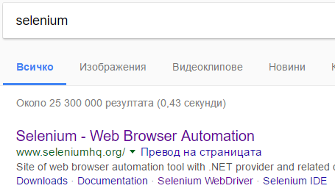

## QA Automation

Write a **test** that **open browser** and navigate to [**http://www.softuni.bg**](http://www.softuni.bg). Then by using **navigation bar** navigate to QA Automation course page.

**Assert** that there are heading tag **<h1>** and that contains **"**QA Automation - септември 2019**"**

### Examples



## Automationpractice Registration

Write a **test** for test case below:

1. Open Chrome
2. Navigate to <http://automationpractice.com/index.php>
3. Click "Sign In"
4. Enter valid email in "Create an Account" section
5. Click "Create an account"
6. Validate that same email is set to email field in registration form

### Examples

